Arduino Clock
This is an easy project to assemble- just one main board and two shields, but gives a fully functional, easy to read clock display which retains the time, even when disconnected from power. You could leave it on your desk plugged into a USB port on your computer, so that it powers up whenever the computer is on.

Shopping List:
1 x XC4410 Duinotech Uno Board
1 x XC4536 Data Log Shield
1 x XC4454 LCD Shield

Connections:
All the connections are made with interconnects on the shield, but the following are the important pins:

Duinotech | Data Log Shield | LCD Shield | Function
5V | 5V | 5V | Power
GND | GND | GND | Ground
A4(SDA) | A4(SDA) |  | I2C Data
A5(SCL) | A5(SCL) |  | I2C Clock
D10 | D10 |  | SD Card Select
D11 | D11 |  | Master In Slave Out
D12 | D12 |  | Master Out Slave In
D13 | D13 |  | Serial Clock
A0 | A0 |  | Pushbuttons
D4 |  | D4 | Data Bit 4
D5 |  | D5 | Data Bit 5
D6 |  | D6 | Data Bit 6
D7 |  | D7 | Data Bit 7
D8 |  | D8 | Register Select
D9 |  | D9 | Enable

The Data Log Shield also has an SD card slot, so the pinouts for this are shown as well, even though they’re not used in this project.

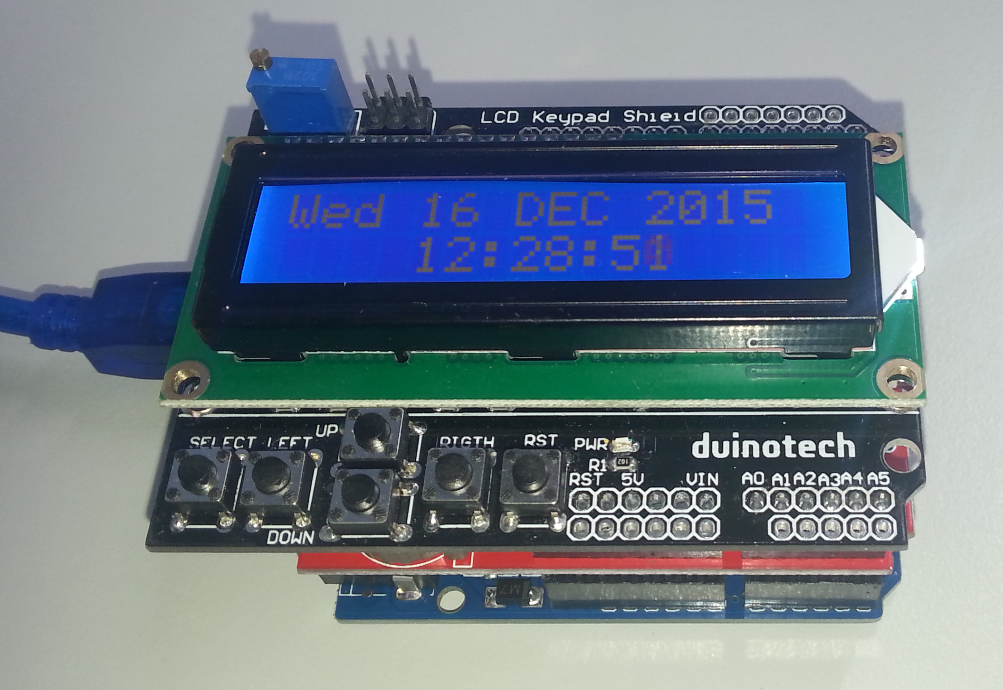

Stack the shields, first the Data Log Shield onto the Uno, then the LCD Shield onto the Data Log Shield. Make sure you’ve got the RTClib Library installed. The project also uses the Wire and LCD libraries, but they are included with the Arduino IDE.

Compile and upload the code to the board, and the clock should display a time and date (which probably isn’t right). The clock can be adjusted by pressing select, then left and right to choose which field to edit, and up and down to adjust the field. The seconds can only be set to zero rather than adjusted up or down. Press select again to return to clock mode.

Improvements:
With the addition of a buzzer module, the code could be modified to act as an alarm clock. Once the clock is set, the sketch on the main board can be changed, so the buttons could be reprogrammed to operate different functions, such as a countdown timer.

Code:
// Date and time functions using a DS1307 RTC connected via I2C and Wire lib
// Code based around demo in https://github.com/adafruit/RTClib/archive/master.zip
// pushbutton code from https://arduino-info.wikispaces.com/LCD-Pushbuttons
// Modified by Tim Blythman Decmeber 2015

#include <Wire.h>
#include "RTClib.h"
#include <LiquidCrystal.h>

//pin for buttons
#define KEYPIN A0
//button constants
#define btnRIGHT 6
#define btnUP 5
#define btnDOWN 4
#define btnLEFT 3
#define btnSELECT 2
#define btnNONE (-1)

RTC_DS1307 rtc;
LiquidCrystal lcd(8, 9, 4, 5, 6, 7); //LiquidCrystal lcd(RS, E, b4, b5, b6, b7);

char daysOfTheWeek[7][12] = {"Sunday", "Monday", "Tuesday", "Wednesday", "Thursday", "Friday", "Saturday"};
char monthsOfTheYear[12][4]={"JAN","FEB","MAR","APR","MAY","JUN","JUL","AUG","SEP","OCT","NOV","DEC"};
char dOfTheWeek[7][4]={"Sun","Mon","Tue","Wed","Thu","Fri","Sat"};
char setphase=0; //to know whether we are setting the clock or not
char setpos=0; //setting y/m/d/h/m/s
char cursorx[6]={5,7,14,5,8,11}; //where to place cursor in set mode
char cursory[6]={0,0,0,1,1,1};

DateTime now; //set as global so we can update between loops

void setup () {
Serial.begin(9600);
lcd.begin(16, 2);
lcd.clear();
if (! rtc.begin()) {
Serial.println("Couldn't find RTC");
while (1);
}
}

void loop () {
if(!setphase){now = rtc.now();} //only update clock if we're not in setting mode

dobuttons(); //respond to button presses

Serial.print(now.year(), DEC);
Serial.print('/');
Serial.print(now.month(), DEC);
Serial.print('/');
Serial.print(now.day(), DEC);
Serial.print(" (");
Serial.print(dOfTheWeek[now.dayOfTheWeek()]);
Serial.print(") ");
Serial.print(now.hour(), DEC);
Serial.print(':');
Serial.print(now.minute(), DEC);
Serial.print(':');
Serial.print(now.second(), DEC);
Serial.println();

lcd.setCursor(0, 0);
lcd.print(dOfTheWeek[now.dayOfTheWeek()]);
lcd.print(" ");
lcd.print(tens(now.day()), DEC);
lcd.print(units(now.day()), DEC);
lcd.print(' ');
lcd.print(monthsOfTheYear[now.month()-1]);
lcd.print(' ');
lcd.print(now.year(), DEC);
lcd.print(' ');

lcd.setCursor(4, 1);
lcd.print(tens(now.hour()), DEC);
lcd.print(units(now.hour()), DEC);
lcd.print(':');
lcd.print(tens(now.minute()), DEC);
lcd.print(units(now.minute()), DEC);
lcd.print(':');
lcd.print(tens(now.second()), DEC);
lcd.print(units(now.second()), DEC);
lcd.print(' ');
lcd.setCursor(cursorx[setpos],cursory[setpos]); //place flashing cursor in set mode
delay(150); //short enough to pick up brief keypresses
}

char tens(int n){return (n/10)%10;} //to help show leading zeroes

char units(int n){return n%10;} //to help show leading zeros

int read_LCD_buttons(){
int adc_key_in = 0;
adc_key_in = analogRead(KEYPIN); // read the value from the sensor
delay(5); //switch debounce delay. Increase this delay if incorrect switch selections are returned.
int k = (analogRead(KEYPIN) - adc_key_in); //gives the button a slight range to allow for a little contact resistance noise
if (5 < abs(k)) return btnNONE; // double checks the keypress. If the two readings are not equal +/-k value after debounce delay, it tries again.
// my buttons when read are centered at these valies: 0, 144, 329, 504, 741
// we add approx 50 to those values and check to see if we are close
if (adc_key_in > 1000) return btnNONE; // We make this the 1st option for speed reasons since it will be the most likely result
if (adc_key_in < 50) return btnRIGHT;
if (adc_key_in < 195) return btnUP;
if (adc_key_in < 380) return btnDOWN;
if (adc_key_in < 555) return btnLEFT;
if (adc_key_in < 790) return btnSELECT;
return btnNONE; // when all others fail, return this...
}

void dobuttons(){
int key;
key = read_LCD_buttons();
if(key==btnSELECT){
if(setphase==0){setphase=1;lcd.blink();setpos=3;} //phase 1 is starting set mode, but select key still pressed, turn cursor on, default to changing hour
if(setphase==2){setphase=3;lcd.noBlink();rtc.adjust(now);} //phase 3 is ending set mode, but select key still pressed, turn cursor off, need to update RTC to edited time
}
if(key==btnNONE){
if(setphase==1){setphase=2;} //phase 2 is in set mode select key released
if(setphase==3){setphase=0;} //phase 0 is normal mode, select key released
}

if(setphase==2){ //respond to keys in setting mode
if(key==btnLEFT){setpos=setpos-1;if(setpos<0){setpos=5;}}
if(key==btnRIGHT){setpos=setpos+1;if(setpos>5){setpos=0;}}

int syear,smon,sday,shour,smin,ssec;
syear=now.year();
smon=now.month();
sday=now.day();
shour=now.hour();
smin=now.minute();
ssec=now.second();
if(key==btnUP){
if(setpos==0){sday=sday+1;if(sday>31){sday=1;}}
if(setpos==1){smon=smon+1;if(smon>12){smon=1;}}
if(setpos==2){syear=syear+1;}
if(setpos==3){shour=shour+1;if(shour>23){shour=0;}}
if(setpos==4){smin=smin+1;if(smin>59){smin=0;}}
if(setpos==5){ssec=0;}
rtc.adjust(DateTime(syear, smon, sday, shour, smin, ssec)); //update clock
now = rtc.now(); //reload into now
}
if(key==btnDOWN){
if(setpos==0){sday=sday-1;if(sday<1){sday=31;}}
if(setpos==1){smon=smon-1;if(smon<1){smon=12;}}
if(setpos==2){syear=syear-1;}
if(setpos==3){shour=shour-1;if(shour<0){shour=23;}}
if(setpos==4){smin=smin-1;if(smin<0){smin=59;}}
if(setpos==5){ssec=0;}
rtc.adjust(DateTime(syear, smon, sday, shour, smin, ssec)); //update clock
now = rtc.now(); //reload into now
}
}
}

